# **Software Requirement Specification**

**Project Name: Easy Car Rental**

**Document History:**

|  |  |  |  |  |  |
| --- | --- | --- | --- | --- | --- |
| **Version** | **Prepare By** | **Prepare Date** | **Review By** | **Review Date** | **Change Log** |
|  |  |  |  |  |  |
|  |  |  |  |  |  |
|  |  |  |  |  |  |
|  |  |  |  |  |  |
|  |  |  |  |  |  |

## **INDEX**

1. **Problem Statement Index**

1.1. Problem Statement & Description

2. **Project Scope (Goal of Project)**

3. **As-Is (Existing) Business Process**

3.1 UML Diagram on Low Level (Flowchart)

3.2 Description

3.3 UML Diagram on Low Level (Activity)

3.4 Description

4. **To-Be (Solution /End Product) Business Process**

4.1. UML Diagram on Low Level (Flowchart)

4.2 Description

4.3 UML Diagram on Low Level (Activity)

4.4 Description

4.5 Use Cases

4.6 Description

4.7 Sequence Diagram

4.8 Description

4.9 Data Flow Description

4.10 Description

4.11 ER and Class Diagram

4.12Description

5. **Functional Requirements**

5.1. Use case 1 Specification – User Registration

5.2. Use case 2 Specification – Login User

5.3. Use case 3 Specification – Trip Details

5.4. Use case 4 Specification – Select Car

5.5. Use case 5 Specification – Poc & Pac Details

5.6. Use case 6 Specification – Preview Details

5.7. Use case 7 Specification – Make Payment

5.8. Use case 8 Specification – Payment Confirmation

### **Problem Statement:**

#### **1.1 Problem Statement**

Our organization’s current manual processes are inefficient, error-prone, and time-consuming. These issues lead to delays, inconsistencies, and higher operational costs, hindering productivity and scalability. To overcome these challenges, we aim to develop software that automates these processes, enhancing efficiency, accuracy, and overall business performance.

**Description:**

Our project involves designing and developing a software solution to automate the existing manual processes within our organization. The key objectives of this project are to streamline workflows, reduce human errors, and improve operational efficiency. By automating repetitive tasks, we will free up valuable time for our employees to focus on more strategic and value-added activities.

* Workflow Automation: Streamline repetitive tasks and ensure consistency.
* Data Management: Centralize data storage with validation and error-checking.
* User-Friendly Interface: Provide an intuitive interface with customizable dashboards.
* Integration Capabilities: Ensure seamless integration with existing systems.
* Scalability and Flexibility: Design for growth and adaptability.
* Enhanced Security: Implement robust data protection measures.

### **Project Scope (Goal Of Project)**

The goal of this project is to develop a comprehensive software solution to automate our organization's manual processes, thereby increasing operational efficiency, accuracy, and overall productivity.

### **As-Is (Existing) Business Process**

#### **3.1 UML Diagram on Low Level (Flowchart)**

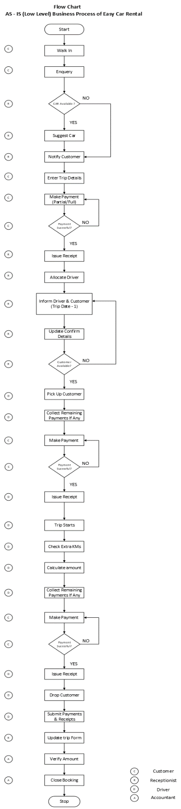

#### **3.2 Description**

In the current manual process for car rental, customers initiate their rental by physically visiting the car rental office to either register or log in. They engage in a face-to-face discussion with the staff to provide trip details such as pick-up and drop-off locations, dates, and times. The staff then manually searches for available cars that fit the customer's requirements, which involves checking physical or digital records. Customers review the available options, apply filters as needed, and select a car based on their preferences. Both passenger and driver details are recorded manually by the staff, which involves filling out physical forms or entering information into a manual system.

Once the car is selected, the customer chooses a payment method from options available at the office and completes the transaction in person. The staff generates a booking confirmation and issues a receipt to the customer on the spot. On the designated day, the customer returns to the office to pick up the car, where their identity is verified, and any remaining formalities are completed. During the rental period, customers have the option to contact the company for support via phone or in-person visits, adding to the need for manual tracking and response. At the end of the rental, the customer returns the car to the office, where staff conduct a physical inspection for any damages. Additional charges, if applicable, are processed manually, and the customer is solicited for feedback. This process is characterized by extensive human interaction and paperwork, resulting in a time-consuming experience that is susceptible to errors and inefficiencies.

#### **3.3 UML Diagram on Low Level (Activity Diagram)**

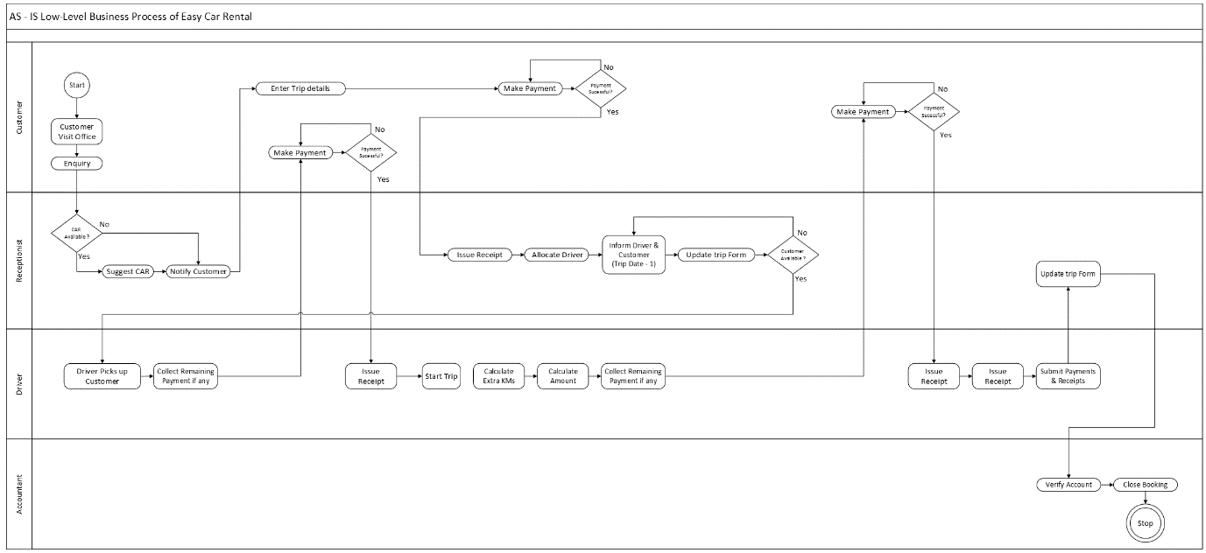

#### **3.4 Description**

The activity diagram for the manual car rental process outlines the steps from customer registration to car return. The customer begins by visiting the office to register or log in, then discusses trip details with the staff. The staff manually searches for available cars, and the customer selects one based on their preferences. Passenger and driver details are recorded manually, and payment is processed in person. On the pick-up date, the customer verifies their identity and receives the car. During the rental period, the customer can seek support if needed. Finally, the car is returned, inspected for damages, and any additional charges are processed. The process is characterized by significant manual interaction and paperwork.

### **To-Be (Solution /End Product) Business Process**

#### **4.1 UML Diagram on Low Level (Flowchart)**

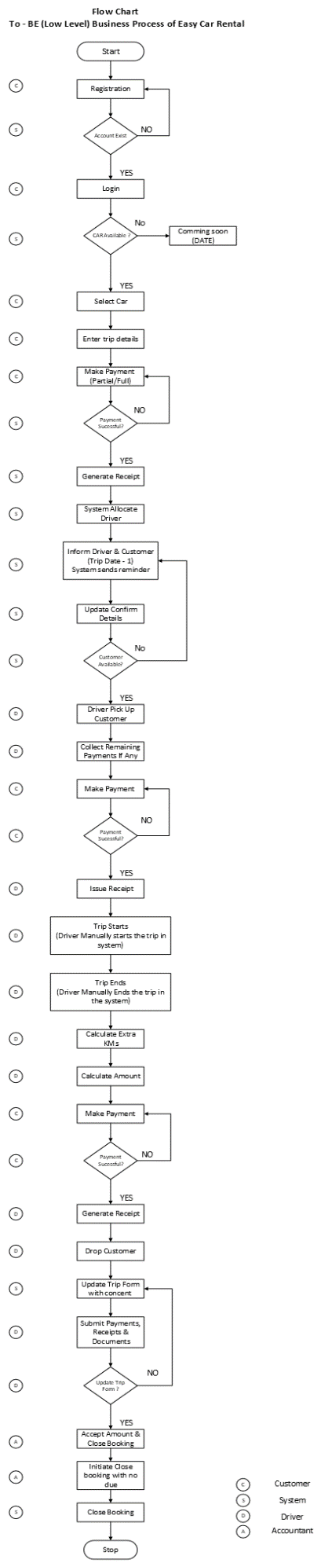

#### **4.2 Description**

In the automated car rental process, customers begin by registering or logging into the app, where they input essential trip details such as pick-up and drop-off locations, dates, and times. The app then processes these details to search for available cars. Users can view and filter car options online according to their preferences, such as transmission type and car type. They select a car and enter required passenger and driver information directly into the app. Payment is completed securely through integrated gateways, with options like credit card, debit card, UPI, or QR code scanning. If the payment is not successfully completed, the system prompts the user to reattempt payment. The process will only proceed once the payment is confirmed. Upon successful payment, the system generates an electronic booking confirmation and receipt, which are sent to the user via email and made available for download. Additional charges, if any, are managed through the system, and user feedback is collected through automated surveys. This streamlined, automated approach minimizes manual intervention, speeds up the process, and reduces the potential for errors, providing a more efficient and user-friendly rental experience

#### **4.3 UML Diagram on Low Level (Activity Diagram)**

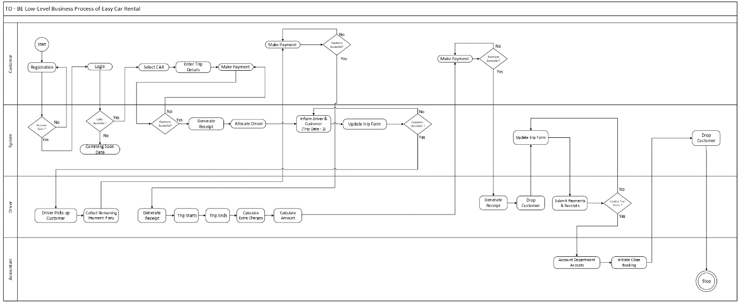

#### **4.4 Description**

In the automated process for the easy car rental app, the activity diagram illustrates a streamlined flow from customer registration to car return. Customers begin by logging into the app or registering if they are new users. They then input trip details, such as pick-up and drop-off locations, dates, and times, which the system uses to search and display available cars. Customers can browse and filter car options online, select their preferred vehicle, and provide passenger and driver information directly through the app.

Payment is processed through secure, integrated payment gateways. Once payment is confirmed, the system automatically generates and sends a booking confirmation and receipt to the customer. Throughout the rental period, customers can access support via in-app messaging or chat. At the end of the rental, the car return process is managed through the app, where any additional charges are automatically calculated and processed. Customer feedback is collected through automated surveys. This automated workflow reduces manual steps, accelerates the rental process, and minimizes the potential for errors, enhancing overall efficiency and user experience.

#### **4.5 Use Case Diagram**

##### **4.5.1 End User ECR (Image)**

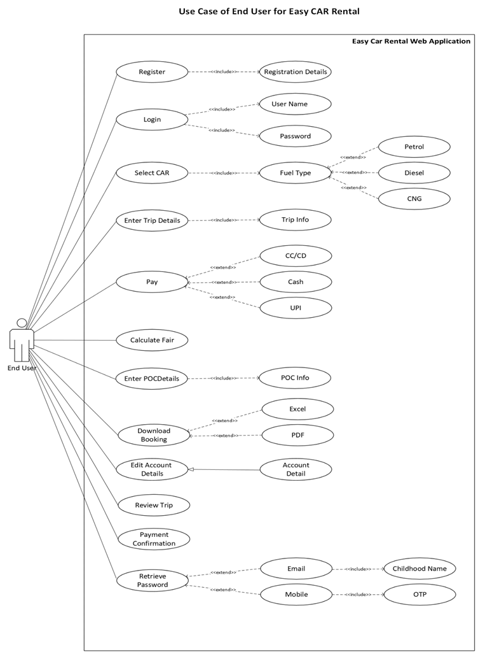

##### **4.5.2 Admin ECR (Image)**

##### **4.5.3 Customer Support ECR (Image)**

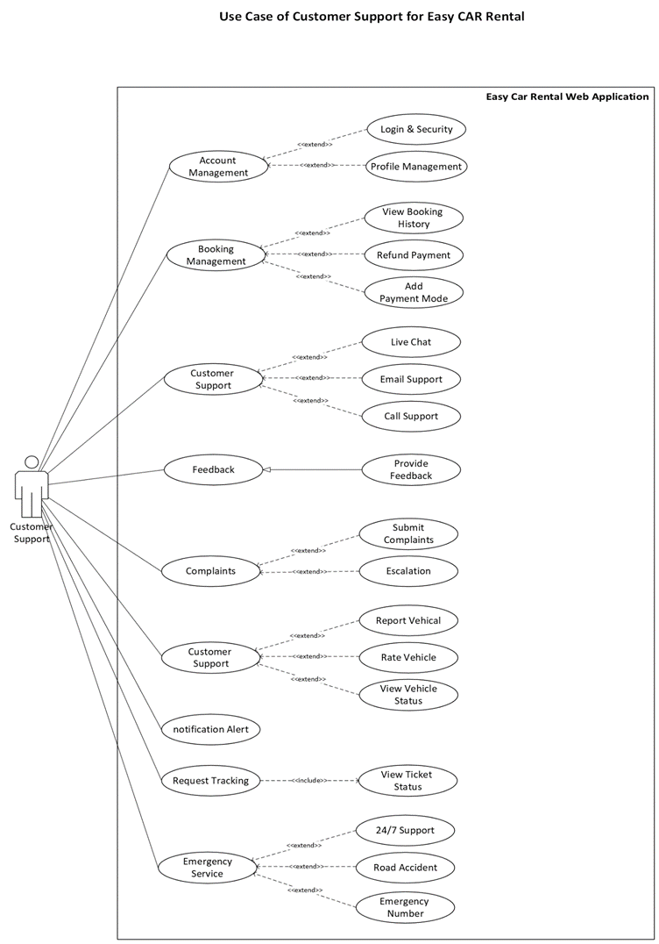

##### **10.5.4 Driver ECR (Image)**

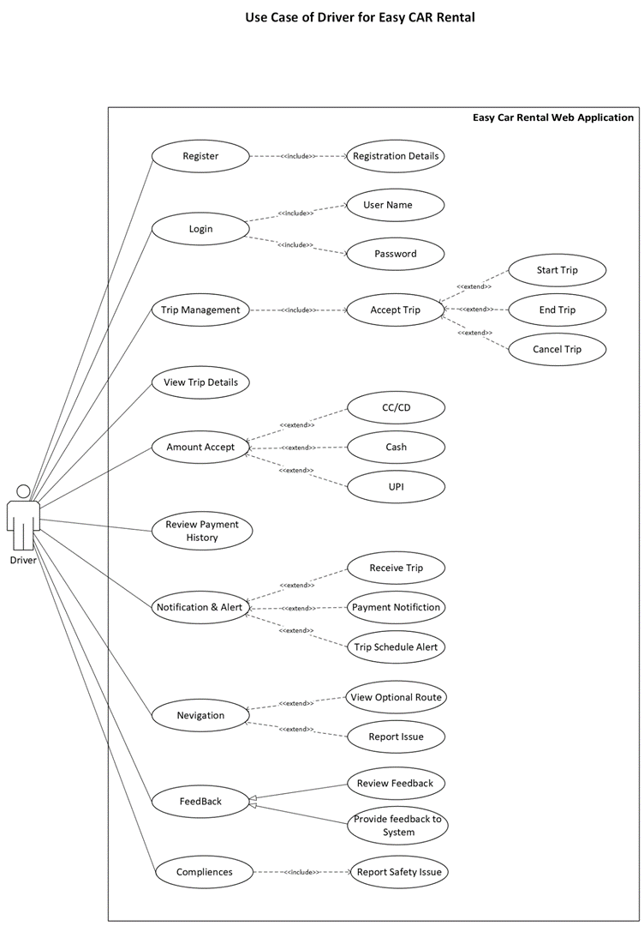

#### **4.6 Description**

End User initiates their journey by registering or logging in to access personalized services. They input their trip details, such as pick-up and drop-off locations, dates, and times, which the system uses to search for available cars. Users can then filter and select a vehicle, provide necessary passenger and driver information, and complete the payment through secure gateways. Once payment is successful, the system sends an electronic booking confirmation and receipt. Users can manage their bookings, including modifications and cancellations, and complete the return process through the app.

The Admin oversees the system's operations, managing user accounts, updating vehicle inventory, and monitoring financial transactions. They generate reports for analysis and decision-making and handle user complaints and feedback to maintain service quality.

Drivers update their availability, receive trip details, and ensure vehicles are picked up and dropped off according to the schedule. They report any issues with vehicles or the rental process to the admin for resolution.

Customer Support assists users with booking issues, policy inquiries, and technical problems. They manage and resolve complaints to ensure user satisfaction and provide help with any difficulties encountered during the rental period.

#### **4.7 Sequence Diagram**

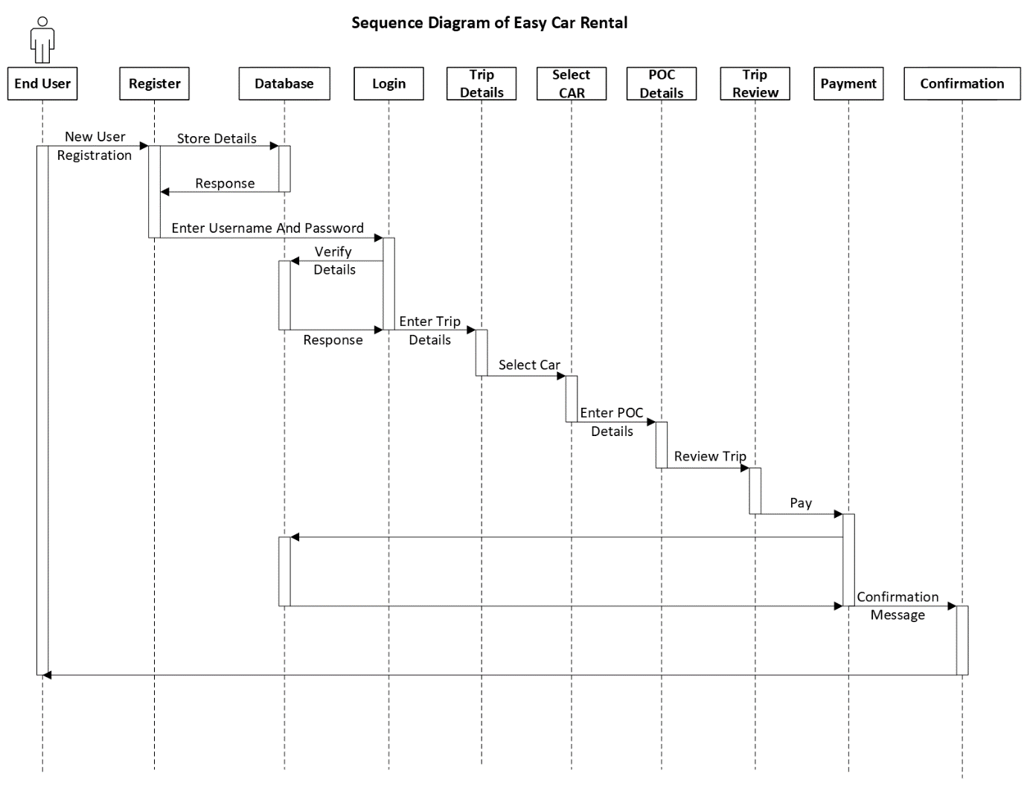

#### **4.8 Description**

The sequence diagram for the easy car rental app illustrates the dynamic interactions between the user and the system throughout the car rental process. Initially, the user registers or logs in to the app, triggering a session where they enter trip details, including pick-up and drop-off locations, dates, and times. The system processes these inputs and retrieves available car options from its database. The user then selects a car, and the system prompts them to enter passenger and driver details. Following this, the user proceeds to the payment stage, where they choose a payment method and complete the transaction. The system verifies the payment, generates a booking confirmation, and sends an electronic receipt to the user. Throughout the process, the system interacts with the user interface to provide real-time updates and feedback. If any issues arise, the user can contact customer support through the app. This sequence ensures a streamlined, efficient rental experience from booking to payment and final vehicle return.

#### **4.9 Data Flow Diagram**

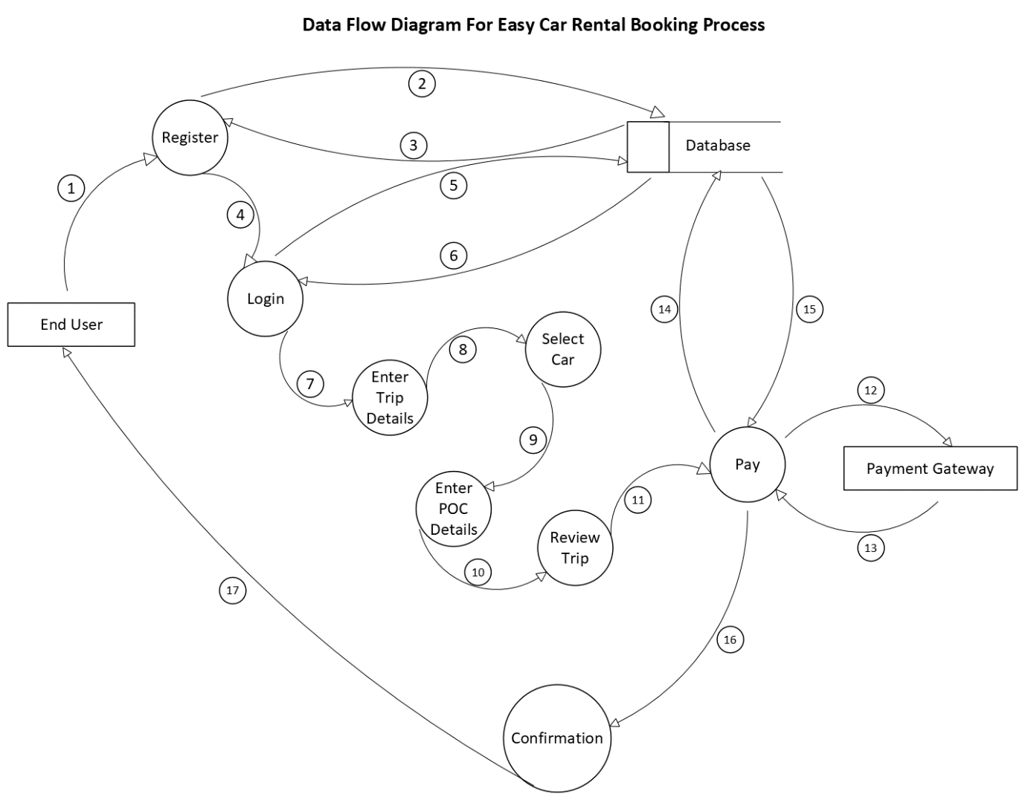

#### **4.10 Description**

The Data Flow Diagram (DFD) for the easy car rental app represents the flow of information between various components of the system. At the core of the diagram are the primary processes: User Registration and Login, Trip Details Entry, Car Selection, Payment Processing, and Booking Confirmation.

Data flows into the system as users input their trip details, which are then processed to search for available cars. The system interacts with the Car Inventory Database to retrieve and display car options based on user criteria. Once a car is selected, user and payment information is captured and validated. The Payment Gateway processes the payment, and upon successful completion, the system updates the Booking Database and generates a confirmation.

The DFD also highlights the interactions between users and customer support, enabling users to seek assistance or provide feedback. Data flows between the system and users, ensuring that information is updated in real-time and facilitating smooth transitions between booking steps. This diagram provides a comprehensive view of how data is managed and processed within the app, illustrating the seamless integration of user inputs, system operations, and database interactions.

#### **4.11 ER And Class Diagram**

##### **4.11.1 ER Diagram**

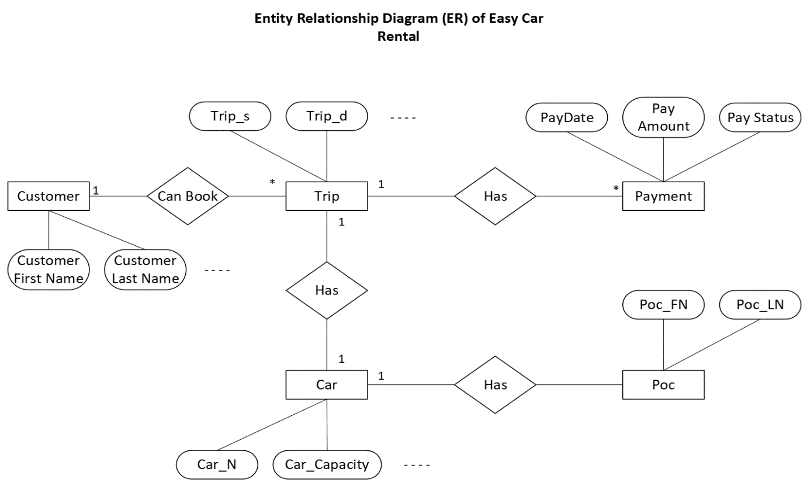

##### **4.11.2 Class Diagram**

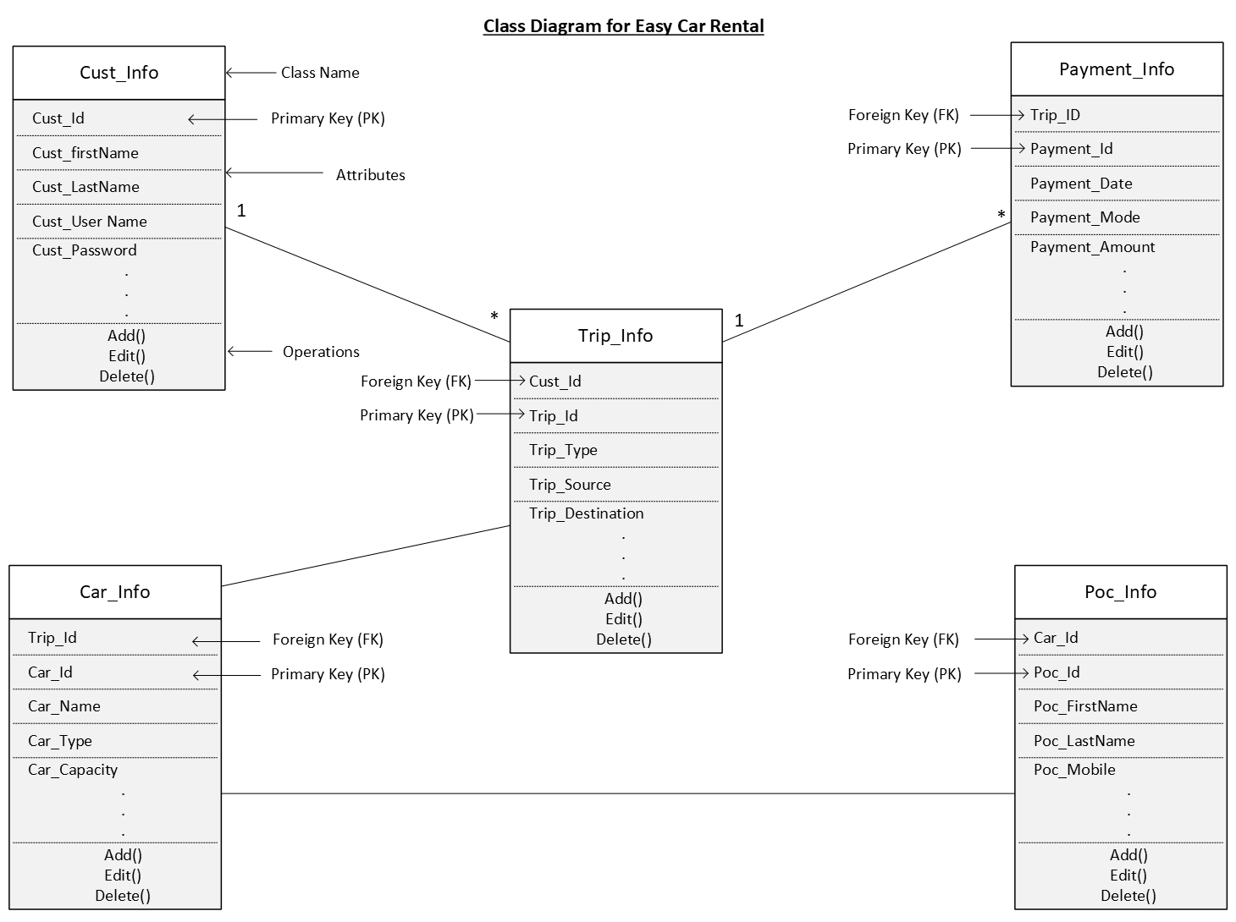

#### **4.12 Description**

##### **4.12.1 Entity Relationship (ER) Diagram for Easy Car Rental**

The Entity Relationship (ER) Diagram for an easy car rental app visualizes the relationships between various entities involved in the car rental process. This diagram provides a high-level overview of the data structure, showing how different entities interact with each other within the system. By illustrating the entities, their attributes, and their relationships, the ER diagram helps in understanding the logical data model of the car rental system.

##### **4.12.2 Class Diagram for Easy Car Rental**

The Class Diagram for an easy car rental app provides a static view of the system's structure, showing the system's classes, their attributes, methods, and the relationships among the classes. It helps in designing the system's architecture by defining the roles and responsibilities of each class. Here's a detailed explanation:

Key Components of the Class Diagram

1. Classes: Represent the main components of the system.
2. Attributes: Variables within classes that hold data related to objects.
3. Operations (Methods): Functions or procedures that define behaviors of the class.
4. Primary Key: A unique attribute or a combination of attributes that uniquely identify an object.
5. Foreign Key: An attribute that creates a link between two classes.

### **Functional Requirements**

#### **5.1 Use Case 1 – User Registration**

|  |  |  |  |  |  |  |  |  |  |  |  |  |
| --- | --- | --- | --- | --- | --- | --- | --- | --- | --- | --- | --- | --- |
| Use Case ID: | | | | Ucid001 | | | | | | Prepared By Pratik | | |
|  | | | | | | | | | | Prepared Date: 26/07/2024 | | |
| **Use Case Name: New User Can Register** | | | | | | | | | | | | |
|  | | | | | | | | | | | | |
| Actors: New User | | | | | | | | | | | | |
| **Pre-Condition** | | | | | | | | | | | | |
| User must be 18+ | | | | | | | | | | | | |
| **Successful Post Condition** | | | | | | | | **Unsuccessful Post Condition** | | | | |
| 1. Show Pop-up window with message   "User Registration Successful”  2. Cilck on 'ok' button & navigate to login page | | | | | | | | 1. Stay on Registration Page 2. Show validation message bellow field name in color 'Red' font 'Arial' size 10 3. Please ref validation message in field validation table. | | | | |
| **Basic Flow** | | | | | | | | **Alternate Flow** | | | | |
| 1. CIick on 'Register' link on Top right Corner of Home Page. 2. Fill mandatory fields. 3. Click on 'Submit' button | | | | | | | | 1. Click on 'Register' link on footer & prepayment page. 2. Fill mandatory fields 3. CIick on 'Submit' button | | | | |
| Field Validation Table | | | | | | | | | | | | |
| Sr.  No. | Field Name | Control Type | Data Type | Length | Default Value | Other Value | Functional Requirement | | Business Rule | | Validation Rule | Validation Message |
| 1 | First Name | Text Box | Character | 150 | Please Enter- First Name | NA | Please Enter First Name | | NA | | 1. Mandatory | For validation Rule 1 show below message.  “Please Enter First Name” |
| 2. No space Before/After /In between | For validation Rule 2 show below  message. “Please Enter First Name without Space” |
| 3.Characler only | For validation Rule 3 show below message. "'Please Enter character only" |
| 2 | Last Name | Text Box | Character | 150 | Please Enter- Last Name | NA | Please Enter Last Name | | NA | | 1. Mandatory | 1. For validation Rule 1 show below message: “Please Enter Last Name” |
| 2. No space Before/After/In between | 2. For validation Rule 2 show below message: “Please Enter Last Name without Space” |
| 3. Character only | 3. For validation Rule 3 show below message: "Please Enter character only" |
| 3 | Gender | Radio Button | Character | 1 | Male | Female, Other | Please Select Gender | | NA | | 1. Mandatory | 1. For validation Rule 1 show below message: “Please Select Gender” |
| 4 | Registration Type | Text Box | Character | 50 | Enter Registration Type | Driver, User | Please Enter Registration Type | | NA | | 1. Mandatory | 1. For validation Rule 1 show below message: “Please Enter Registration Type” |
| 5 | State | Text Box | Character | 100 | Enter Your State | NA | Please Enter State | | NA | | 1. Mandatory | 1. For validation Rule 1 show below message: “Please Enter State” |
| 2. No space Before/After/In between | 2. For validation Rule 2 show below message: “Please Enter State without Space” |
| 3. Character only | 3. For validation Rule 3 show below message: "Please Enter character only" |
| 6 | City | Text Box | Character | 100 | Enter Your City | NA | Please Enter City | | NA | | 1. Mandatory | 1. For validation Rule 1 show below message: “Please Enter City” |
| 2. No space Before/After/In between | 2. For validation Rule 2 show below message: “Please Enter City without Space” |
| 3. Character only | 3. For validation Rule 3 show below message: "Please Enter character only" |
| 7 | Email ID | Text Box | Email | 100 | Enter Your Email ID | NA | Please Enter Email ID | | NA | | 1. Mandatory | 1. For validation Rule 1 show below message: “Please Enter Email ID” |
| 2. Valid email format | 2. For validation Rule 2 show below message: “Please Enter a valid Email ID” |
| 8 | Mobile Number | Text Box | Number | 10 | Enter Your Mobile Number | NA | Please Enter Mobile Number | | NA | | 1. Mandatory | 1. For validation Rule 1 show below message: “Please Enter Mobile Number” |
| 2. Valid mobile number format | 2. For validation Rule 2 show below message: “Please Enter a valid Mobile Number” |
| 9 | OTP | Text Box | Number | 6 | Enter OTP | NA | Please Enter OTP | | NA | | 1. Mandatory | 1. For validation Rule 1 show below message: “Please Enter OTP” |
| 10 | Password | Text Box | Password | 100 | Set Password | NA | Please Enter Password | | NA | | 1. Mandatory | 1. For validation Rule 1 show below message: “Please Enter Password” |
| 2. Minimum 8 characters | 2. For validation Rule 2 show below message: “Password must be at least 8 characters” |
| 11 | Re-Enter Password | Text Box | Password | 100 | Confirm Password | NA | Please Confirm Password | | NA | | 1. Mandatory | 1. For validation Rule 1 show below message: “Please Confirm Password” |
| 2. Must match password | 2. For validation Rule 2 show below message: “Passwords do not match” |
| 12 | Terms & Condition | Check Box | Boolean | 1 | NA | Checked/Unchecked | Please accept Terms & Condition | | NA | | 1. Mandatory | 1. For validation Rule 1 show below message: “Please accept the Terms & Conditions” |

#### **5.2 Use Case 2 – Login User**

|  |  |  |  |  |  |  |  |  |  |  |  |  |
| --- | --- | --- | --- | --- | --- | --- | --- | --- | --- | --- | --- | --- |
| Use Case ID: | | | | Ucid002 | | | | | | Prepared By Pratik | | |
|  | | | | | | | | | | Prepared Date: 26/07/2024 | | |
| **Use Case Name: New User Can login** | | | | | | | | | | | | |
|  | | | | | | | | | | | | |
| Actors: New User | | | | | | | | | | | | |
| **Pre-Condition** | | | | | | | | | | | | |
| 1. User must be Registers 2. User should have valid credential | | | | | | | | | | | | |
| **Successful Post Condition** | | | | | | | | **Unsuccessful Post Condition** | | | | |
| 1. User successfully logged  2. Cilck on ‘Login’ button & navigate to next page | | | | | | | | 1. Stay on login page  2. Show validation message bellow field name in color 'Red' font 'Arial' size 10 3. Please ref validation message in field validation table. | | | | |
| **Basic Flow** | | | | | | | | **Alternate Flow** | | | | |
| 1. Go to Login Page  2. Fill mandatory fields. 3. Click on ‘Login’ button | | | | | | | | NA | | | | |
| Field Validation Table | | | | | | | | | | | | |
| Sr.  No. | Field Name | Control Type | Data Type | Length | Default Value | Other Value | Functional Requirement | | Business Rule | | Validation Rule | Validation Message |
| 1 | Email ID | Text Box | Email | 100 | Enter Your Email ID | NA | Please Enter Email ID | | NA | | 1. Mandatory | 1. For validation Rule 1 show below message: “Please Enter Email ID” |
| 2. Valid email format | 2. For validation Rule 2 show below message: “Please Enter a valid Email ID” |
| 2 | Password | Text Box | Password | 100 | Enter Your Password | NA | Please Enter Password | | NA | | 1. Mandatory | 1. For validation Rule 1 show below message: “Please Enter Password” |
| 2. Minimum 8 characters | 2. For validation Rule 2 show below message: “Password must be at least 8 characters” |
| 3. No spaces allowed | 3. For validation Rule 3 show below message: “Password cannot contain spaces” |
| 3 | Remember Me | Check Box | Boolean | 1 | NA | Checked/Unchecked | Remember Me Option | | NA | | 1. Optional | NA |
| 4 | Forget Password Link | Hyperlink | NA | NA | NA | NA | Navigate to Reset Password | | NA | | 1. Clickable | NA |
| 5 | Login Button | Button | NA | NA | NA | NA | Submit Login Form | | NA | | 1. Clickable | NA |
| 6 | Login with Facebook | Button | NA | NA | NA | NA | Alternative Login Option | | NA | | 1. Clickable | NA |
| 7 | Login with Apple | Button | NA | NA | NA | NA | Alternative Login Option | | NA | | 1. Clickable | NA |
| 8 | Login with Gmail | Button | NA | NA | NA | NA | Alternative Login Option | | NA | | 1. Clickable | NA |

#### **5.3 Use Case 3 – Trip Details**

|  |  |  |  |  |  |  |  |  |  |  |  |  |
| --- | --- | --- | --- | --- | --- | --- | --- | --- | --- | --- | --- | --- |
| Use Case ID: | | | | Ucid003 | | | | | | Prepared By Pratik | | |
|  | | | | | | | | | | Prepared Date: 26/07/2024 | | |
| **Use Case Name: New User Enter Trip Details** | | | | | | | | | | | | |
|  | | | | | | | | | | | | |
| Actors: New User | | | | | | | | | | | | |
| **Pre-Condition** | | | | | | | | | | | | |
| The user is logged in | | | | | | | | | | | | |
| **Successful Post Condition** | | | | | | | | **Unsuccessful Post Condition** | | | | |
| 1. navigates to the next page to see available cars. | | | | | | | | 1. User is unable to proceed due to incomplete or invalid trip details. 2. Error messages prompt the user to correct the details. | | | | |
| **Basic Flow** | | | | | | | | **Alternate Flow** | | | | |
| 1. User Login 2. Enter Pick up and drop off details | | | | | | | | 1. User Log in. 2. Search assistance | | | | |
| Field Validation Table | | | | | | | | | | | | |
| Sr.  No. | Field Name | Control Type | Data Type | Length | Default Value | Other Value | Functional Requirement | | Business Rule | | Validation Rule | Validation Message |
| 1 | Pick-up Location |  | Alphanumeric | 150 | Enter Pick-up Location | NA | Select from icon or text | | 1. Location can contain alphanumeric characters, spaces, and special characters like comma, period, and hyphen. | | 1. Mandatory | 1. For validation Rule 1 show below message: “Please Enter Pick-up Location” |
| 2. Selectable from location icon | | 2. No leading/trailing spaces | 2. For validation Rule 2 show below message: “Please Enter Pick-up Location without leading/trailing spaces” |
| 3. Must not contain multiple consecutive spaces | | 3. Alphanumeric, spaces, and specific special characters only | 3. For validation Rule 3 show below message: "Please Enter a valid location (alphanumeric, spaces, commas, periods, and hyphens only)" |
| 4. Case insensitive | | 4. No consecutive spaces | 4. For validation Rule 4 show below message: "Please Enter Pick-up Location without consecutive spaces" |
| 5. Minimum length of 3 characters | | 5. Minimum length of 3 characters | 5. For validation Rule 5 show below message: "Pick-up Location must be at least 3 characters long" |
| 2 | Drop-off Location | Text Box/Icon | Alphanumeric | 150 | Enter Drop-off Location | NA | Select from icon or text | | 1. Location can contain alphanumeric characters, spaces, and special characters like comma, period, and hyphen. | | 1. Mandatory | 1. For validation Rule 1 show below message: “Please Enter Drop-off Location” |
| 2. Selectable from location icon | | 2. No leading/trailing spaces | 2. For validation Rule 2 show below message: “Please Enter Drop-off Location without leading/trailing spaces” |
| 3. Must not contain multiple consecutive spaces | | 3. Alphanumeric, spaces, and specific special characters only | 3. For validation Rule 3 show below message: "Please Enter a valid location (alphanumeric, spaces, commas, periods, and hyphens only)" |
| 4. Case insensitive | | 4. No consecutive spaces | 4. For validation Rule 4 show below message: "Please Enter Drop-off Location without consecutive spaces" |
| 5. Minimum length of 3 characters | | 5. Minimum length of 3 characters | 5. For validation Rule 5 show below message: "Drop-off Location must be at least 3 characters long" |
| 3 | Pick-up Date | Date Picker/Calendar Icon | Date | NA | Select Pick-up Date | NA | Select from present date | | NA | | 1. Mandatory | 1. For validation Rule 1 show below message: “Please Select Pick-up Date” |
|  |  |  |  |  |  |  |  | |  | | 2. Must be a present or future date | 2. For validation Rule 2 show below message: “Pick-up Date must be a present or future date” |
| 4 | Drop-off Date | Date Picker/Calendar Icon | Date | NA | Select Drop-off Date | NA | Select after pick-up date | | NA | | 1. Mandatory | 1. For validation Rule 1 show below message: “Please Select Drop-off Date” |
| 2. Must be after pick-up date | 2. For validation Rule 2 show below message: “Drop-off Date must be after Pick-up Date” |
| 5 | Pick-up Time | Time Picker/Dropdown | Time | NA | 10.00 AM | User Selection | Default 10:00 AM or user input | | NA | | 1. Mandatory | 1. For validation Rule 1 show below message: “Please Select Pick-up Time” |
| 2. Must be within operational hours | 2. For validation Rule 2 show below message: “Pick-up Time must be within operational hours” |
| 6 | Drop-off Time | Time Picker/Dropdown | Time | NA | 10.00 AM | User Selection | Default 10:00 AM or user input | | NA | | 1. Mandatory | 1. For validation Rule 1 show below message: “Please Select Drop-off Time” |
| 2. Must be within operational hours | 2. For validation Rule 2 show below message: “Drop-off Time must be within operational hours” |
| 7 | Get Car Button | Button | NA | NA | NA | NA | Submit trip details | | NA | | 1. Clickable | NA |
| 8 | Language Select | Dropdown | Character | NA | English | Multiple Languages | Default language English | | NA | | 1. Selectable | NA |
| 9 | User Details (Profile) | Hyperlink | NA | NA | NA | NA | Opens user profile | | NA | | 1. Clickable | NA |
| 10 | Logout Button | Button | NA | NA | NA | NA | Logout user | | NA | | 1. Clickable | NA |
| 11 | 24x7 Toll-Free Call | Button | NA | NA | NA | NA | Initiate toll-free call | | NA | | 1. Clickable | NA |
| 12 | 24x7 Email Support | Button | NA | NA | NA | NA | Open email support | | NA | | 1. Clickable | NA |

#### **5.4 Use Case 4 – Select Car**

|  |  |  |  |  |  |  |  |  |  |  |  |  |
| --- | --- | --- | --- | --- | --- | --- | --- | --- | --- | --- | --- | --- |
| Use Case ID: | | | | Ucid004 | | | | | | Prepared By Pratik | | |
|  | | | | | | | | | | Prepared Date: 26/07/2024 | | |
| **Use Case Name: User Select Car** | | | | | | | | | | | | |
|  | | | | | | | | | | | | |
| Actors: New User | | | | | | | | | | | | |
| **Pre-Condition** | | | | | | | | | | | | |
| Trip details (pick-up and drop-off locations, dates, and times) are entered and available. | | | | | | | | | | | | |
| **Successful Post Condition** | | | | | | | | **Unsuccessful Post Condition** | | | | |
| 1. The user successfully selects a car. 2. The user is able to proceed to the next step with the selected car details saved. | | | | | | | | 1. If no car is selected, the user cannot proceed to the next step. 2. An error message prompts the user to select a car. | | | | |
| **Basic Flow** | | | | | | | | **Alternate Flow** | | | | |
| 1. Enter Trip Details 2. View Available Cars 3. Select Car 4. User clicks the Next Button to proceed to the next step. | | | | | | | | Search and Filter:   1. User enters a search term in the Search Bar to find specific car models or brands. 2. User applies filters (Transmission Type, Seats, Car Type, Fuel Type) to narrow down the options. 3. User sorts the car list by price, car age, or rating. | | | | |
| Field Validation Table | | | | | | | | | | | | |
| Sr.  No. | Field Name | Control Type | Data Type | Length | Default Value | Other Value | Functional Requirement | | Business Rule | | Validation Rule | Validation Message |
| 1 | Search Bar | Text Box | String | 150 | Enter car model or brand | NA | Search for cars | | 1. Can search by car model or brand | | NA | NA |
| 2 | Location | Label | String | 150 | Selected locations | NA | Display pick-up and drop-off locations | | 1. Read-only; shows selected locations | | NA | NA |
| 3 | Date | Label | String | NA | Selected dates and times | NA | Display pick-up and drop-off dates and times | | 1. Read-only; shows selected dates and times | | NA | NA |
| 4 | Car Selection List | Selectable List | Object List | NA | Available cars | NA | Display list of available cars | | 1. List of available cars based on search and filters | | 1. Clickable for selection | 1. “Please select a car” |
| 5 | Selected Car Highlight | Visual Highlight | String | NA | NA | NA | Highlight selected car | | 1. Only one car can be selected at a time | | 1. Car card should be highlighted in blurred green color | NA |
| 6 | Next Button | Button | String | NA | NA | NA | Navigate to next step | | 1. Enabled only after a car is selected | | 1. Clickable only when a car is selected | 1. “Please select a car to proceed” |
| 7 | Sort By | Dropdown | List | NA | NA | Price (Low to High, High to Low), Car Age (New to Old, Old to New), Rating (Low to High, High to Low) | Sort car list | | 1. Sorting options should include price, car age, and rating | | 1. Should allow selection of one sorting option | NA |
| 8 | Filter | Section | List | NA | NA | NA | Filter cars based on criteria | | 1. Filter criteria includes Transmission Type, Seats, Car Type, Fuel Type | | NA | NA |
| 9 | Transmission Type | Checkbox Group | String | NA | NA | Manual, Automatic | Filter by transmission type | | 1. User can select one, multiple, or all options | | 1. Should allow multiple selections | NA |
| 10 | Seats | Checkbox Group | String | NA | NA | 4/5 seats, 6/9 seats | Filter by seat capacity | | 1. User can select one, multiple, or all options | | 1. Should allow multiple selections | NA |
| 11 | Car Type | Checkbox Group | String | NA | NA | Hatchback, Sedan, Luxury, SUV | Filter by car type | | 1. User can select one, multiple, or all options | | 1. Should allow multiple selections | NA |
| 12 | Fuel Type | Checkbox Group | String | NA | NA | Diesel, Petrol, CNG | Filter by fuel type | | 1. User can select one, multiple, or all options | | 1. Should allow multiple selections | NA |

#### **5.5 Use Case 5 – Poc & Pax Details**

|  |  |  |  |  |  |  |  |  |  |  |  |  |
| --- | --- | --- | --- | --- | --- | --- | --- | --- | --- | --- | --- | --- |
| Use Case ID: | | | | Ucid005 | | | | | | Prepared By Pratik | | |
|  | | | | | | | | | | Prepared Date: 26/07/2024 | | |
| **Use Case Name: POC & PAX Details** | | | | | | | | | | | | |
|  | | | | | | | | | | | | |
| Actors: User | | | | | | | | | | | | |
| **Pre-Condition** | | | | | | | | | | | | |
| 1. The user has selected a car and reached the Passenger and Driver Details page. 2. The system has populated the driver details. | | | | | | | | | | | | |
| **Successful Post Condition** | | | | | | | | **Unsuccessful Post Condition** | | | | |
| 1. The passenger details are entered correctly. 2. The user can proceed to the next step. 3. The system saves the passenger information. | | | | | | | | 1. If the passenger details are incomplete or incorrect, the user cannot proceed. 2. The system prompts the user to correct or complete the information. | | | | |
| **Basic Flow** | | | | | | | | **Alternate Flow** | | | | |
| 1. Enter trip details, select the car 2. Driver details are shown in read-only labels. 3. User fills in editable text boxes for passenger 4. User ensures all fields are correctly filled out. 5. Navigate:   User clicks Next Button to proceed to the next step (enabled only when all required fields are filled). | | | | | | | | System Error:   1. If a system error occurs, the user is shown an error message. 2. The user may be redirected back to the Passenger and Driver Details page or to a previous step for resolution. | | | | |
| Field Validation Table | | | | | | | | | | | | |
| Sr.  No. | Field Name | Control Type | Data Type | Length | Default Value | Other Value | Functional Requirement | | Business Rule | | Validation Rule | Validation Message |
| 1 | Driver Name | Label | String | 100 | NA | NA | Display driver’s name | | Read-only; non-editable | | NA | NA |
| 2 | Driver License Number | Label | String | 50 | NA | NA | Display driver’s license number | | Read-only; non-editable | | NA | NA |
| 3 | Driver Contact Number | Label | String | 50 | NA | NA | Display driver’s contact number | | Read-only; non-editable | | NA | NA |
| 4 | Passenger Name | Text Box | String | 100 | NA | NA | Enter passenger’s name | | Editable | | Mandatory | “Please enter passenger’s name” |
| 5 | Passenger Age | Text Box | Numeric | 3 | NA | NA | Enter passenger’s age | | Editable; must be a valid age | | Mandatory, Numeric | “Please enter a valid age” |
| 6 | Passenger Contact Number | Text Box | String | 50 | NA | NA | Enter passenger’s contact number | | Editable | | Mandatory | “Please enter a contact number” |
| 7 | Passenger Email | Text Box | String | 100 | NA | NA | Enter passenger’s email address | | Editable | | Mandatory, Email Format | “Please enter a valid email address” |
| 8 | Back Button | Button | Button | NA | NA | NA | Navigate to previous step | | NA | | NA | NA |
| 9 | Next Button | Button | Button | NA | NA | NA | Navigate to next step | | Enabled only when all required details are filled | | NA | “Please complete all required fields” |
| 10 | Home Button | Button | Button | NA | NA | NA | Redirect to Home page | | NA | | NA | NA |
| 11 | Trip Details | Button/Link | Button/Link | NA | NA | NA | Redirect to Trip Details page | | NA | | NA | NA |
| 12 | Select Car | Button/Link | Button/Link | NA | NA | NA | Redirect to Select Car page | | NA | | NA | NA |
| 13 | POC (Passenger) Details | Button/Link | Button/Link | NA | NA | NA | Redirect to Passenger Details page | | NA | | NA | NA |

#### **5.6 Use Case 6 – Preview Details**

|  |  |  |  |  |  |  |  |  |  |  |  |  |
| --- | --- | --- | --- | --- | --- | --- | --- | --- | --- | --- | --- | --- |
| Use Case ID: | | | | Ucid006 | | | | | | Prepared By Pratik | | |
|  | | | | | | | | | | Prepared Date: 26/07/2024 | | |
| **Use Case Name: User Preview Details** | | | | | | | | | | | | |
|  | | | | | | | | | | | | |
| Actors: User | | | | | | | | | | | | |
| **Pre-Condition** | | | | | | | | | | | | |
| 1. The user has completed selecting a car, and entering trip and passenger details. 2. The user has reached the Preview Trip Details page to review the entire trip information before proceeding to payment. | | | | | | | | | | | | |
| **Successful Post Condition** | | | | | | | | **Unsuccessful Post Condition** | | | | |
| 1. The trip details are reviewed and confirmed. 2. The user can download the trip details. 3. The user navigates to the next step (payment) successfully. | | | | | | | | 1. If the trip details are incomplete or incorrect, the user is redirected back to the relevant page to correct the details. 2. The user cannot proceed to the next step until all details are accurate. | | | | |
| **Basic Flow** | | | | | | | | **Alternate Flow** | | | | |
| 1. Display Trip Information: Vehicle, driver, and passenger details are shown in read-only format. 2. Navigate:   User clicks Next Button to proceed to the payment page. | | | | | | | | Incomplete or Incorrect Details:   1. User finds inaccuracies in the displayed details. 2. User clicks Back Button or appropriate navigation link to correct the details. 3. User cannot click Next Button until all details are correct. | | | | |
| Field Validation Table | | | | | | | | | | | | |
| Sr.  No. | Field Name | Control Type | Data Type | Length | Default Value | Other Value | Functional Requirement | | Business Rule | | Validation Rule | Validation Message |
| 1 | Vehicle Details | Label | String | NA | NA | NA | Display vehicle details | | Read-only; non-editable | | NA | NA |
| 2 | Driver Details | Label | String | NA | NA | NA | Display driver details | | Read-only; non-editable | | NA | NA |
| 3 | Passenger Details | Label | String | NA | NA | NA | Display passenger details | | Read-only; non-editable | | NA | NA |
| 4 | Download Button | Button | Button | NA | NA | NA | Allow download of trip details | | NA | | NA | NA |
| 5 | Back Button | Button | Button | NA | NA | NA | Navigate to previous step | | NA | | NA | NA |
| 6 | Next Button | Button | Button | NA | NA | NA | Navigate to next step | | Enabled only when all required details are displayed | | NA | “Please ensure all details are correct” |
| 7 | Home Button | Button | Button | NA | NA | NA | Redirect to Home page | | NA | | NA | NA |
| 8 | Trip Details | Button/Link | Button/Link | NA | NA | NA | Redirect to Trip Details page | | NA | | NA | NA |
| 9 | Select Car | Button/Link | Button/Link | NA | NA | NA | Redirect to Select Car page | | NA | | NA | NA |
| 10 | POC (Passenger) Details | Button/Link | Button/Link | NA | NA | NA | Redirect to Passenger Details page | | NA | | NA | NA |

#### **5.7 Use Case 7 – Make Payment**

|  |  |  |  |  |  |  |  |  |  |  |  |  |
| --- | --- | --- | --- | --- | --- | --- | --- | --- | --- | --- | --- | --- |
| Use Case ID: | | | | Ucid007 | | | | | | Prepared By Pratik | | |
|  | | | | | | | | | | Prepared Date: 26/07/2024 | | |
| **Use Case Name: User Make Payment** | | | | | | | | | | | | |
|  | | | | | | | | | | | | |
| Actors: New User | | | | | | | | | | | | |
| **Pre-Condition** | | | | | | | | | | | | |
| 1. The user has navigated to the Payment Details page after successfully selecting a car and entering trip and passenger details. 2. The user is prepared to complete the payment process. | | | | | | | | | | | | |
| **Successful Post Condition** | | | | | | | | **Unsuccessful Post Condition** | | | | |
| 1. The payment is processed successfully. 2. The user is redirected to the Payment Confirmation page. 3. All selected payment options and entered details are recorded correctly. 4. The Make Payment Button is enabled only when a payment mode is selected and all required fields are completed. | | | | | | | | 1. If payment fails or required details are missing, the user remains on the Payment Details page. 2. An error or validation message is displayed, and the Make Payment Button remains disabled until the issues are resolved. | | | | |
| **Basic Flow** | | | | | | | | **Alternate Flow** | | | | |
| 1. Select Payment Method: User chooses a payment option (Credit Card, Debit Card, UPI, or Scan QR). 2. Enter Payment Details 3. Review Details 4. Make Payment 5. Process Payment 6. Confirm Payment | | | | | | | | Payment Mode Not Selected:   1. Make Payment Button remains disabled. 2. Message: “Please select a payment method.” | | | | |
| Field Validation Table | | | | | | | | | | | | |
| Sr.  No. | Field Name | Control Type | Data Type | Length | Default Value | Other Value | Functional Requirement | | Business Rule | | Validation Rule | Validation Message |
| 1 | Payment Mode | Radio Button Group | String | NA | NA | Credit Card, Debit Card, UPI, Scan QR | Display payment options | | Only one payment option can be selected; selected option highlighted in green box | | 1. Highlight selected option in green box | NA |
| 2 | Credit Card Details | Text Box | String | 100 | NA | NA | Enter credit card details | | Visible only when Credit Card is selected | | Mandatory for Credit Card option | “Please enter credit card details” |
| 3 | Debit Card Details | Text Box | String | 100 | NA | NA | Enter debit card details | | Visible only when Debit Card is selected | | Mandatory for Debit Card option | “Please enter debit card details” |
| 4 | UPI Details | Text Box | String | 100 | NA | NA | Enter UPI details | | Visible only when UPI is selected | | Mandatory for UPI option | “Please enter UPI details” |
| 5 | Scan QR Details | Text Box | String | 100 | NA | NA | Enter details after scanning QR code | | Visible only when Scan QR is selected | | Mandatory for Scan QR option | “Please enter details from QR scan” |
| 6 | Make Payment Button | Button | Button | NA | NA | NA | Enable only when payment mode is selected and details are filled | | Enabled only when a payment option is selected and details are filled | | NA | “Please complete all payment details” |
| 7 | Company | Button/Link | Button/Link | NA | NA | NA | Redirect to Company information page | | NA | | NA | NA |
| 8 | About Us | Button/Link | Button/Link | NA | NA | NA | Redirect to About Us page | | NA | | NA | NA |
| 9 | Privacy Policies | Button/Link | Button/Link | NA | NA | NA | Redirect to Privacy Policies page | | NA | | NA | NA |
| 10 | Terms & Conditions | Button/Link | Button/Link | NA | NA | NA | Redirect to Terms & Conditions page | | NA | | NA | NA |
| 11 | Refunds | Button/Link | Button/Link | NA | NA | NA | Redirect to Refunds page | | NA | | NA | NA |
| 12 | Get In Touch | Button/Link | Button/Link | NA | NA | NA | NA | | NA | | NA | NA |
| 13 | Contact Us | Button/Link | Button/Link | NA | NA | NA | Redirect to Contact Us page | | NA | | NA | NA |

#### **5.8 Use Case 8 – Payment Confirmation**

|  |  |  |  |  |  |  |  |  |  |  |  |  |
| --- | --- | --- | --- | --- | --- | --- | --- | --- | --- | --- | --- | --- |
| Use Case ID: | | | | Ucid008 | | | | | | Prepared By Pratik | | |
|  | | | | | | | | | | Prepared Date: 26/07/2024 | | |
| **Use Case Name: View Payment Receipt** | | | | | | | | | | | | |
|  | | | | | | | | | | | | |
| Actors: User | | | | | | | | | | | | |
| **Pre-Condition** | | | | | | | | | | | | |
| 1. User has completed the payment process on the Payment Details page. 2. All required payment details have been entered and a payment method has been selected. 3. The system has processed the payment and generated a confirmation. | | | | | | | | | | | | |
| **Successful Post Condition** | | | | | | | | **Unsuccessful Post Condition** | | | | |
| 1. The payment is confirmed and the payment successful message is displayed. 2. The user is able to download the payment receipt. 3. The user can navigate to other sections of the application via provided links (e.g., Home, Support). | | | | | | | | 1. If the payment processing fails, the user should be redirected back to the Payment Details page or receive an error message indicating the payment was unsuccessful. 2. The user will not see the payment confirmation message or be able to download the receipt. | | | | |
| **Basic Flow** | | | | | | | | **Alternate Flow** | | | | |
| 1. User selects payment method and enters details on the Payment Details page. 2. User submits payment information. 3. System processes the payment. 4. User is redirected to the Payment Confirmation page with: 5. Payment Successful Message. 6. Active Download Receipt Button. 7. Back to Home Button and support section links. 8. User can download receipt, navigate to Home, or access support options. | | | | | | | | Payment Failure:   1. System displays error message. 2. User is redirected to the Payment Details page to correct information. | | | | |
| Field Validation Table | | | | | | | | | | | | |
| Sr.  No. | Field Name | Control Type | Data Type | Length | Default Value | Other Value | Functional Requirement | | Business Rule | | Validation Rule | Validation Message |
| 1 | Payment Successful Message | Text Box | String | NA | Payment Successful | NA | Display a non-editable payment success message | | Read-only; non-editable | | NA | NA |
| 2 | Download Receipt Button | Push Button | Button | NA | NA | NA | Allow download of payment receipt | | NA | | NA | NA |
| 3 | Back to Home Button | Push Button | Button | NA | NA | NA | Redirect to Home page | | NA | | NA | NA |
| 4 | Support Section | Hyperlink | String | NA | NA | NA | Display support options | | NA | | NA | NA |
| 5 | Live Chat Support | Hyperlink | String | NA | NA | NA | Redirect to Live Chat Support | | NA | | NA | NA |
| 6 | Email/Phone Support | Hyperlink | String | NA | NA | NA | Redirect to Email/Phone Support | | NA | | NA | NA |
| 7 | Feedback & Surveys | Hyperlink | String | NA | NA | NA | Redirect to Feedback & Surveys page | | NA | | NA | NA |
| 8 | 24x7 Emergency Contacts | Hyperlink | String | NA | NA | NA | Redirect to 24x7 Emergency Contacts page | | NA | | NA | NA |
| 9 | Raise Tickets & Escalation | Hyperlink | String | NA | NA | NA | Redirect to Raise Tickets & Escalation page | | NA | | NA | NA |
| 10 | FAQs | Hyperlink | String | NA | NA | NA | Redirect to FAQs page | | NA | | NA | NA |